NAME: GUI KAH SIN
MATRIC NO: A23CS0080

REGISTER.PHP - Registration Form Interface
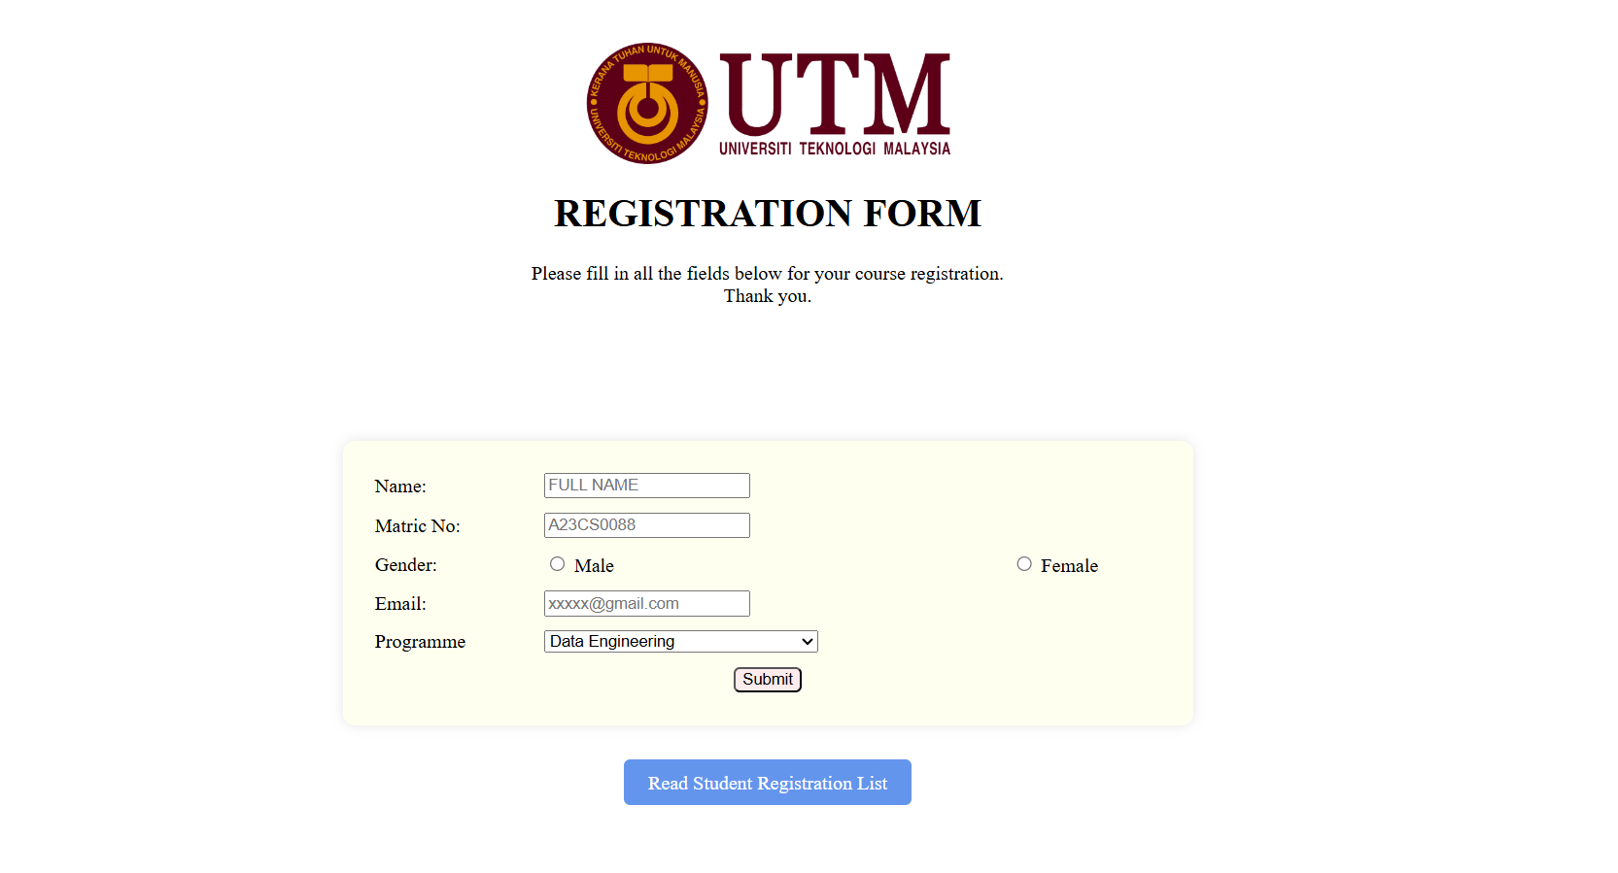
- Fields:
- Name, Matric Number, and Programme: These fields use text input for students to enter their full name, matric number, and select a programme from a dropdown.
- Gender: A radio button field allows students to choose between Male or Female.
- Email: Uses the email input type to ensure correct email formatting.

- Submit Button: Submits the entered data to the database. A notification confirms when the registration is completed successfully.
- Read Student Registration List: This button navigates users to the "Student Information Registration List" page, where they can check their entered details for any errors

READ.PHP – Student Information Registration List
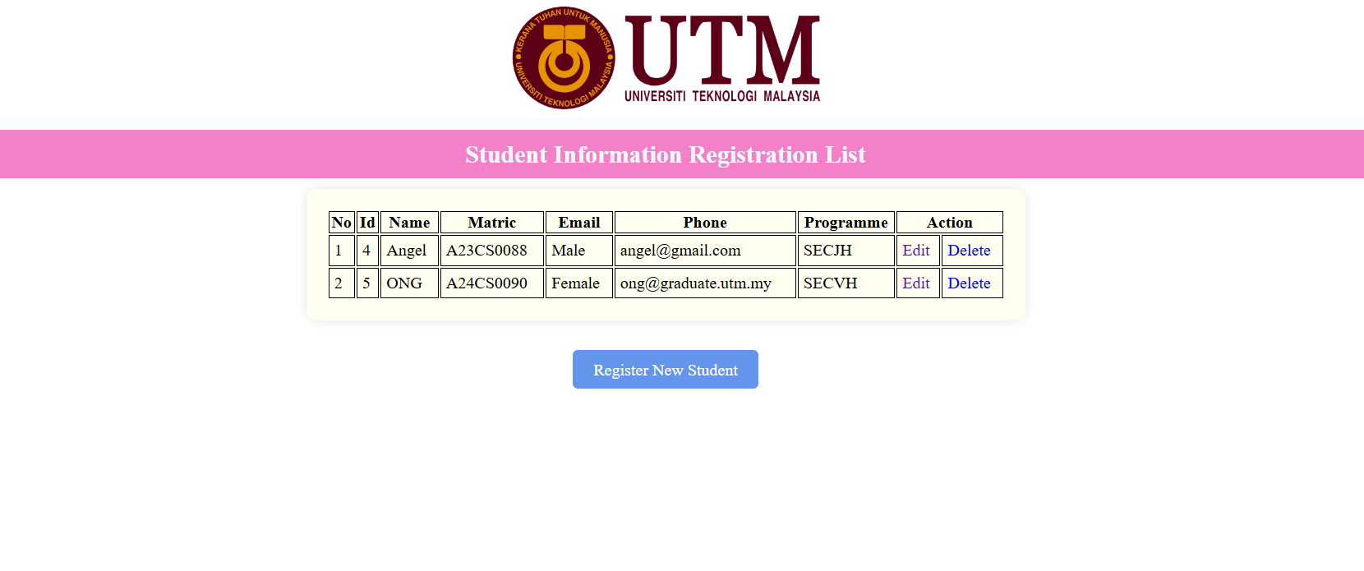
  - Displays a list of all registered students with columns for Name, Matric Number, Gender, Email, and Programme.
  - Edit: Allows students to update any existing information. A notification confirms successful completion of the update.
  - Delete: Removes the selected student’s information.
  - Register New Student: A button at the bottom, which redirects to the registration form for adding new student data.
UPDATE.PHP – Update Information Page

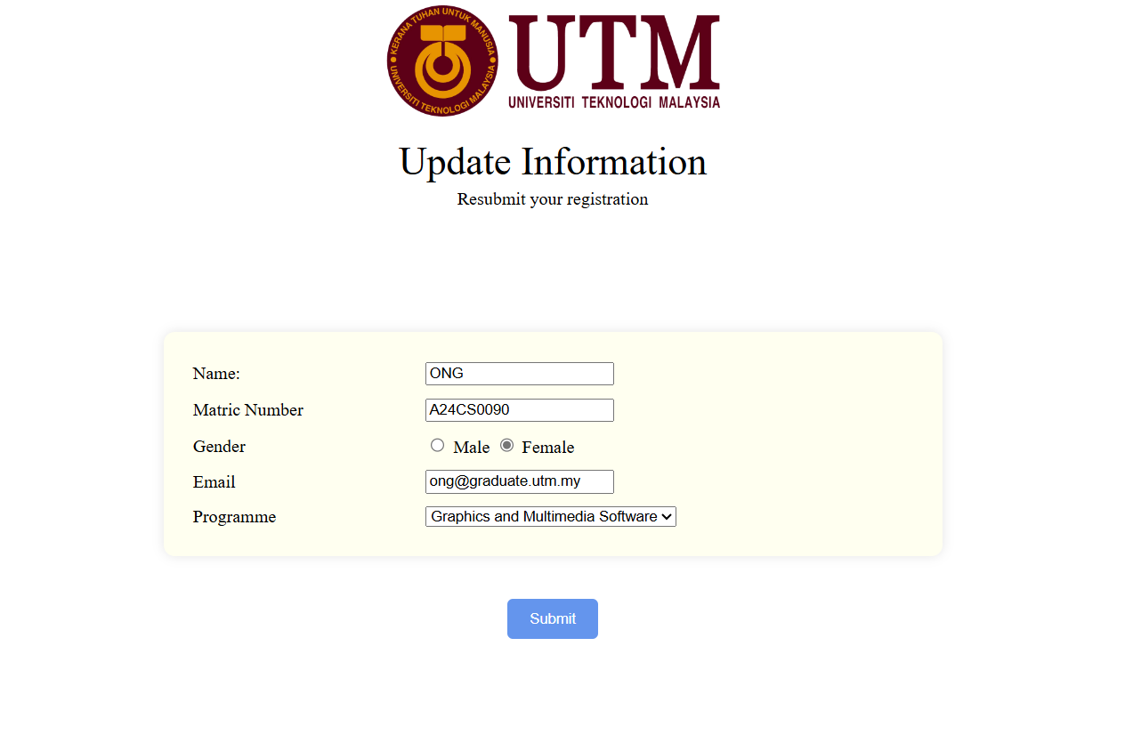
- Similar in structure to the registration form, this page allows students to update their information.
- The only difference is the title "Update Information" instead of "Registration Form."
- After editing, the Submit Button updates the modified data in the database, with a notification confirming a successful update.

